**Financial Modelling**

**Definition**

Financial modelling is a quantitative methodology that integrates mathematics, statistics, and related disciplines to analyze financial data and project a company's future financial performance.

The process of creating a numerical representation of your company’s current financial situation is known as **financial modelling**. This means taking stock of current revenue, expenses, debts, and more.



**Applications of Financial Modelling**:

* **Strategic Business Decisions:** Facilitates informed decision-making on matters such as capital raising, acquisitions, and organizational growth.
* **Business Valuation:** Assists in estimating the economic value of a business or specific assets.
* **Financial Forecasting:** Utilizes historical data and trend analysis to predict future financial outcomes accurately.
* **Risk Management:** Identifies potential risks and evaluates their impact on financial performance

.

* **Regulatory Compliance:** Supports the preparation of financial disclosures in alignment with regulatory requirements.

Historical **‘Microsoft Stocks’** data was extracted using yahoo finance library with the **ticker ‘ MSFT’.**

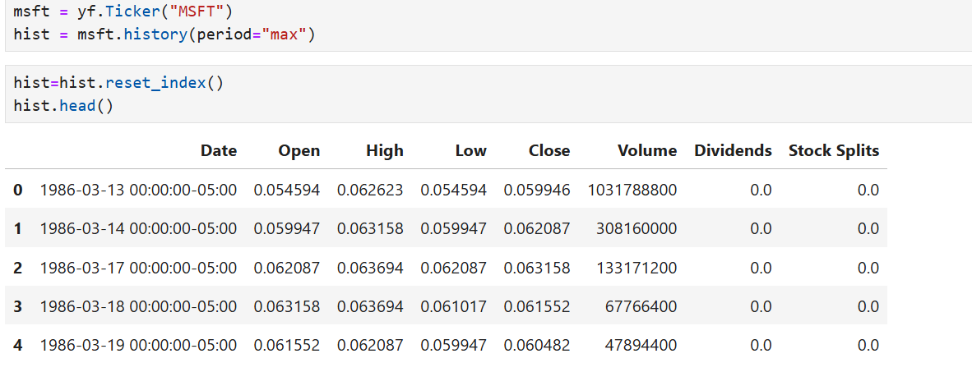

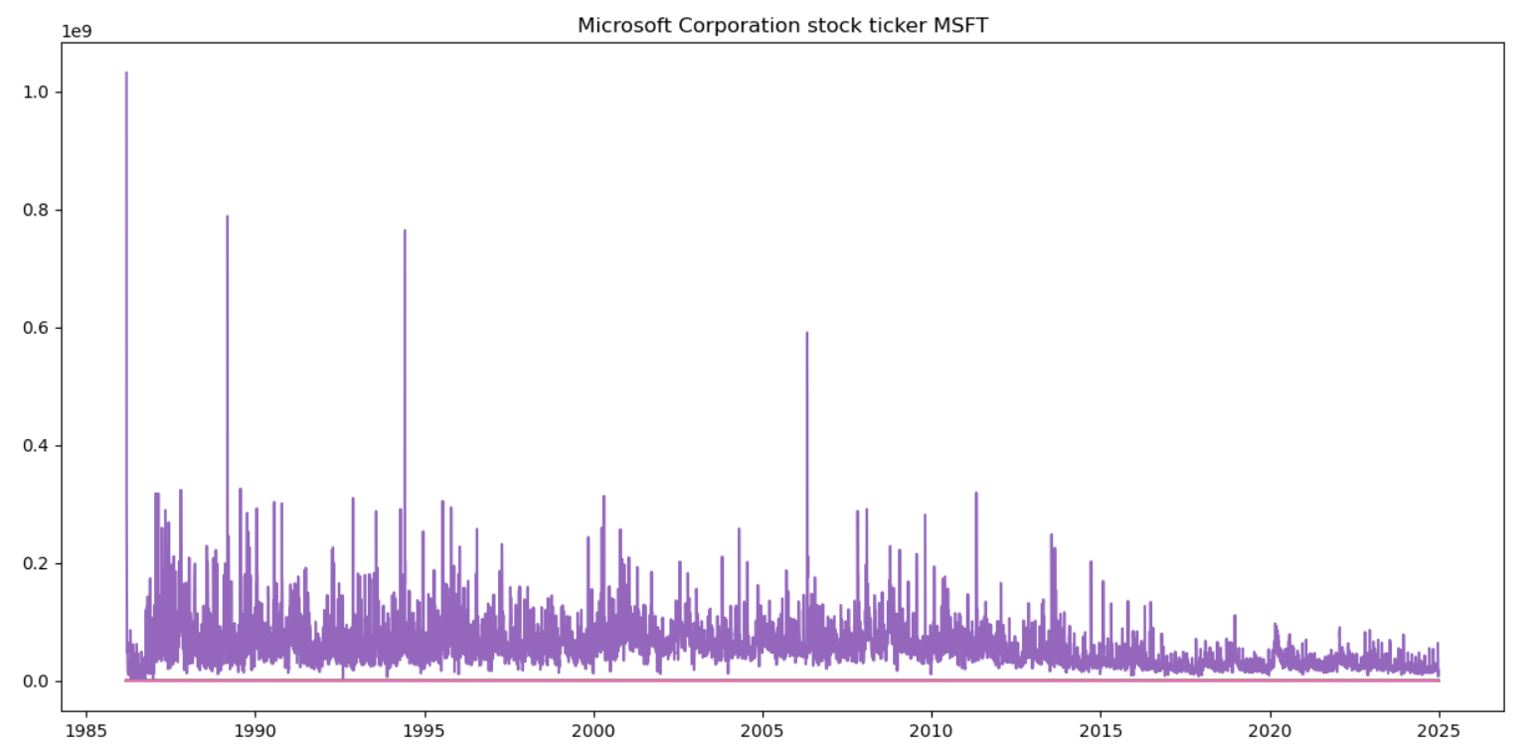

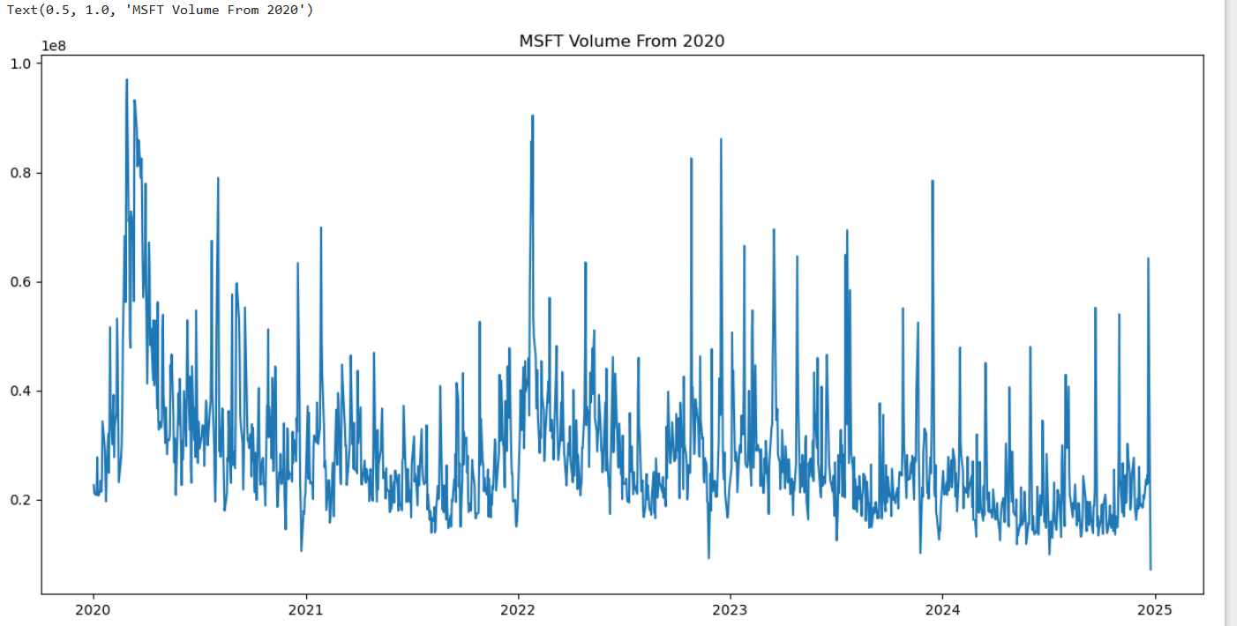

**Investment by firms - Regression**

Analyze the relationship between a firm's investment (invest), its value of capital stock (value), and capital stock (capital).

Data Quality Report

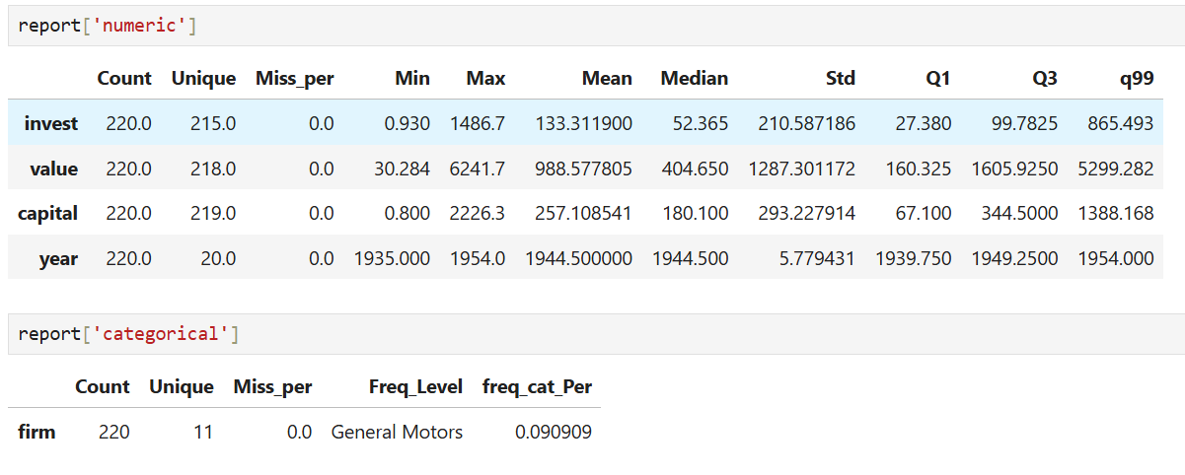

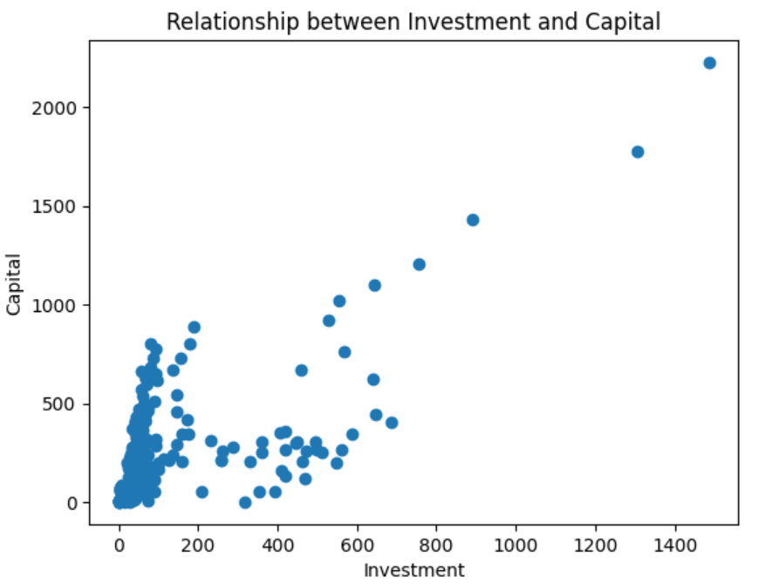

**Models and Hyperparameters**



**Model Comparison**